## **Lab 1 - CSE 3111 Computer Networking Lab**

### **1. Ping Command**

**Command:** ping -c 17 [google.com](http://google.com)

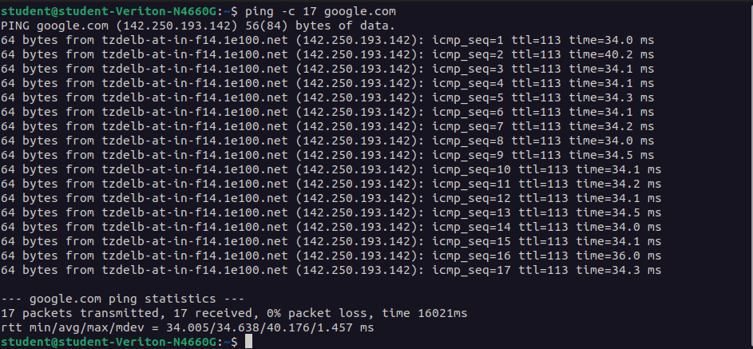

**What it does:**

Sends 17 ICMP echo requests to check network connectivity. Measures round-trip time and packet loss. No reply indicates no connection. Displays minimum, average, and maximum ping times along with stability.

### **2. Traceroute Command**

**Command:** traceroute [google.com](http://google.com)

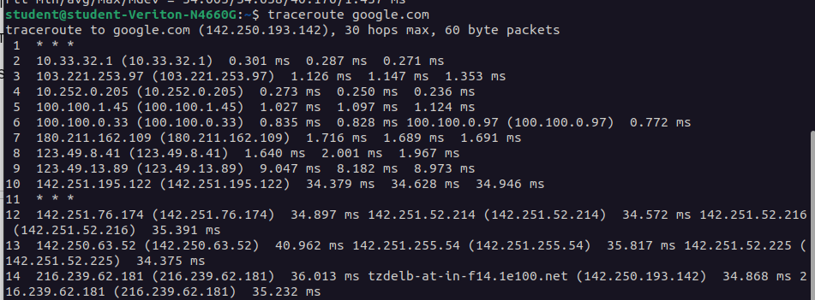

**What it does:**

Traces the route packets take to reach the destination, showing each router (hop) and latency. Helps identify network delays or failures. Resolves domain names to IP addresses before tracing. Defaults to a maximum of 30 hops.

### **3. ifconfig Command**

**Command:** Ifconfig

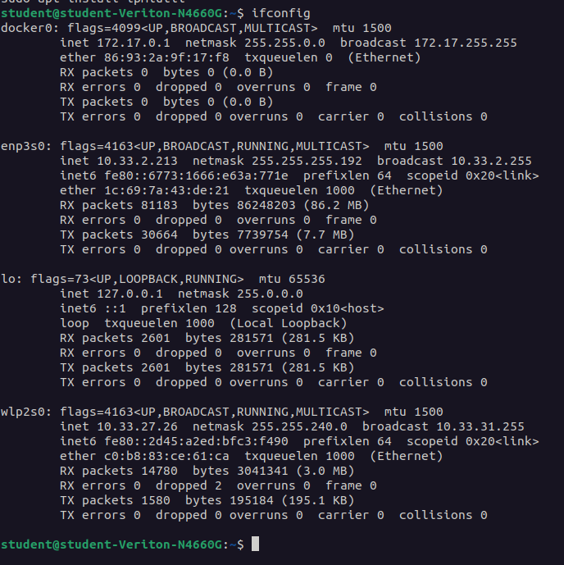

**What it does:**Displays all network interfaces along with their IP addresses, MAC addresses, status flags, and traffic statistics. Useful for checking wired, wireless, virtual, and loopback interfaces.

### **4. arp Command**

**Command:** arp -a

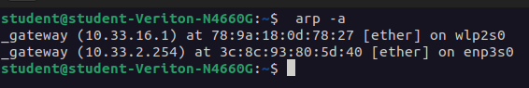

**What it does:**Displays the ARP table that maps IP addresses to MAC addresses within the local network. Allows adding or deleting entries for troubleshooting network issues.

### **5. rarp Command**

**Command:** rarp *(usage varies by system)*

**What it does:**Performs Reverse ARP, resolving MAC addresses to IP addresses. Primarily used by diskless devices to obtain their IP address from a server based on their hardware address.

### **6. nslookup Command**

**Command:** nslookup [google.com](http://google.com)

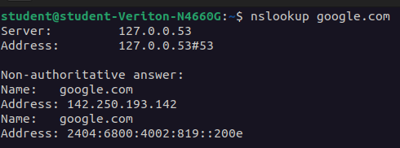

**What it does:**Queries DNS servers to resolve domain names into IP addresses (both IPv4 and IPv6). Useful for troubleshooting DNS resolution problems.

### **7. netstat Command**

**Command:** netstat -a

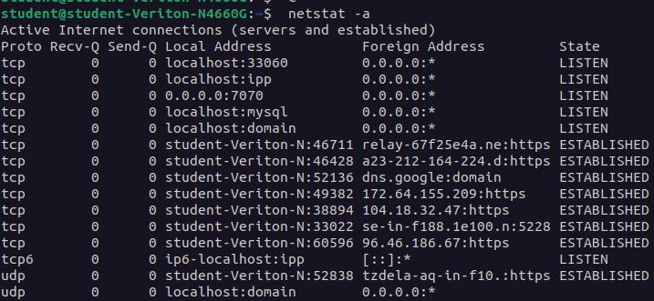

**What it does:**Displays all active TCP and UDP connections, including listening ports. Shows routing tables and network interface statistics. Can also display process IDs associated with network connections.